Lab Assessment Explanation

This document provides an explanation of the HTML concepts and techniques used to create the lab assessment webpage. The structure and components of the file are detailed below.

# 1. Title and Meta Information

The HTML file begins with the `<!DOCTYPE html>` declaration, which specifies the document type. The `<html>` tag defines the root of the HTML document and includes the `lang` attribute to indicate the language as English. The `<head>` section contains metadata such as the character encoding (`UTF-8`), viewport settings for responsiveness, and the document title ('Portfolio').

# 2. Body Content

The `<body>` section contains the main content of the page. It is structured using various HTML elements to organize and display information effectively. Below are the components included:

## 2.1 Headings and Personal Details

|  |  |
| --- | --- |
|  | Headings (`<h1>`, `<h2>`, `<h3>`) are used to display the user's name, section, and roll number. These elements help in organizing content hierarchically. |

## 2.2 Ordered List

|  |  |
| --- | --- |
|  | An ordered list (`<ol>`) is used to display the list of subjects. The `type` attribute specifies the numbering style as numeric (1, 2, 3). Each subject is listed as a `<li>` (list item). |

## 2.3 Table for Marks

|  |  |
| --- | --- |
| A table is created using the `<table>` tag to display subjects and their respective marks. The `border` attribute is set to '1' to create visible borders for the table. The `<tr>` tag defines table rows, `<th>` is used for table headers, and `<td>` for table data. |  |

# Code:

|  |
| --- |
| <!DOCTYPE html>  <html lang="en">  <head>      <meta charset="UTF-8">      <meta name="viewport" content="width=device-width, initial-scale=1.0">      <title>Portfolio</title>  </head>  <body>      <h1>Muhammad Musawar Ali Shah</h1>      <h2>BCS-1E Section</h2>      <h3>24P-0619</h3>      <ol type="1">          <li>Calculus</li>          <li>ICT</li>          <li>Programming Fundamentals</li>      </ol>      <table border="1">          <tr>              <th>Subject</th>              <th>Obtained marks</th>              <th>max marks</th>          </tr>          <tr>              <th>Calculus</th>              <th>79</th>              <th>100</th>          </tr>          <tr>              <th>ICT</th>              <th>90</th>              <th>100</th>          </tr>          <tr>              <th>English Lab</th>              <th>95</th>              <th>100</th>          </tr>      </table>  </body>  </html> |

## Output:

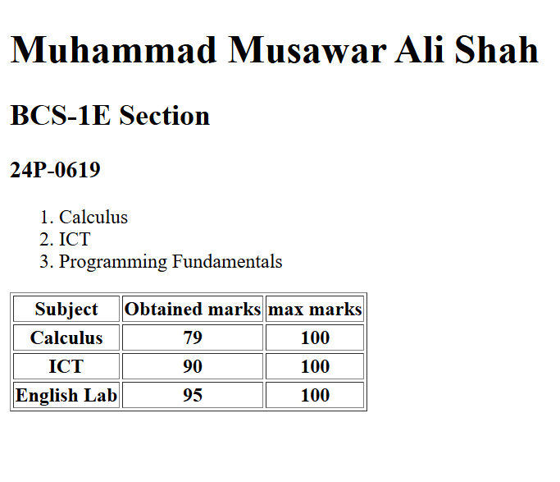

# 3. Conclusion

This HTML file demonstrates the use of basic and essential web development concepts, including metadata, semantic HTML tags, and simple inline styling. The structure ensures readability and clear presentation of information.